STW7071CEM Information Retrieval

Assignment Report

Softwarica College

Submitted By: Manash Bhele

Contents

Abstract 2

Introduction 3

Methodology 4

1. Web Crawling using Scrapy 4

2. Construction of the Query Processor Component 7

a. Cleaning Missing and Irrelevant Values 7

b. Removing Stop Words and Special Characters 7

c. Calcuating TF-IDF and Cosine Similarity 8

3. Subject Classification Using Different Machine Learning Algorithms 10

Results and Discussion 12

References 17

Appendices 18

# Abstract

With the increasing number of online technological devices and consequently, the increase in the volume of data being produced every single second, search engines are a book to humankind. An article which was published in Forbes in 2018 stated that there are 2.5 quintillion bytes of data created each day, around 5 billion searches a day with 77% of those searches conducted on Google (Marr, 2018). A proper search engine is one which provides relevant information for a user’s query within an acceptable time limit. This paper provides an overview of the workings of a search engine. A vertical search engine has been created that returns papers published by Coventry University members. The pureportal website of CU was crawled and the profile information and paper specific data of the members was captured. That information was used to create means for finding the similarity between user’s query and the indexed documents. Given a scientific text as an input, subject classification function has been added. For the search engine, a web interface has been added which provides a similar feel to a traditional search engine. A standalone text classification feature is also present, making use of text classification algorithms such as Random Forest, SVM and LBGM, which takes in a description of any scientific document or article and predicts if it belongs to engineering, business, or arts field.

Keywords: Crawler, Inverted index, TF-IDF, Machine learning, vertical search, cosine similarity, text classification, retrieval, web-interface

# Introduction

General search engines are efficient at providing multitude of results for a query made by a user. These kinds of engines, though powerful and capable of providing a vast range of information, might not be able to provide the result that is desired by and relevant to the user’s needs. With such a plethora of info a user faces, rather than being of help, it might act as an obstacle for the user. To address this problem, a specific kind of search engine called vertical search engine has been made.

A vertical search engine focuses only on a particular category or segment of online content. Some common examples of verticals include shopping, the automobile industry, research literature, homestay platforms. Unlike general search engines, vertical engines use crawlers that only focus on a specific niche or topic (Wikipedia, 2023).

This report demonstrates the working principles of information retrieval processes and the use of machine learning algorithms in text classification. This report also explores the steps, tools and techniques used for creating a search engine and its components. It also provides an insight on the workings of the process of crawling a website for gathering relevant and useful information. The techniques and their implementation are discussed and explained in the following sections.

# Methodology

The primary element indispensable in building a search engine is data. Data relevant for building a vertical search engine must be selected from sources that align with the niche. For this project, the data has been collected from the pure-portal website of Coventry University. The main goal of this project is to crawl the website and gather data on the profiles of the CU academics and their respective published articles to create a vertical search engine for those research papers. The explanations below also describe the text classification system which takes keywords or text as input and identifies its relevant subjects.

The main components and workings of the developed system are described below.

## Web Crawling using Scrapy

The crawling component was accomplished using an open-source web crawling framework called ‘Scrapy.’ Scrapy is a tool used to crawl websites and extract structured data from their pages.

As it is not pre-installed in systems, it was downloaded using the pip installer by executing the command ‘pip install scrapy.’ To make the process of crawling unbounded by hit limitations and straight forward, instead of using Google Scholar, the CU pure-portal website was used. For starting crawling in Scrapy, a ‘start_urls’ value should be initiated. ‘start_urls,’ as the name suggests, is the starting point of the crawling process. In this case, it was set as, “https://pureportal.coventry.ac.uk/en/persons.”

Another important variable to set is “allowed_domains.” A website might have links of various other websites present on a single page. For example, when crawling a certain news site, there might be a link re-directing to social media sites. This might lead the crawler to leave the site to be crawled and start crawling the entire internet. To stop it from doing so, the links “pureportal.coventry.ac.uk” and “pureportal.coventry.ac.uk/en/persons/” were added to allowed domains. It prevents the crawler from crawling beyond these domains.

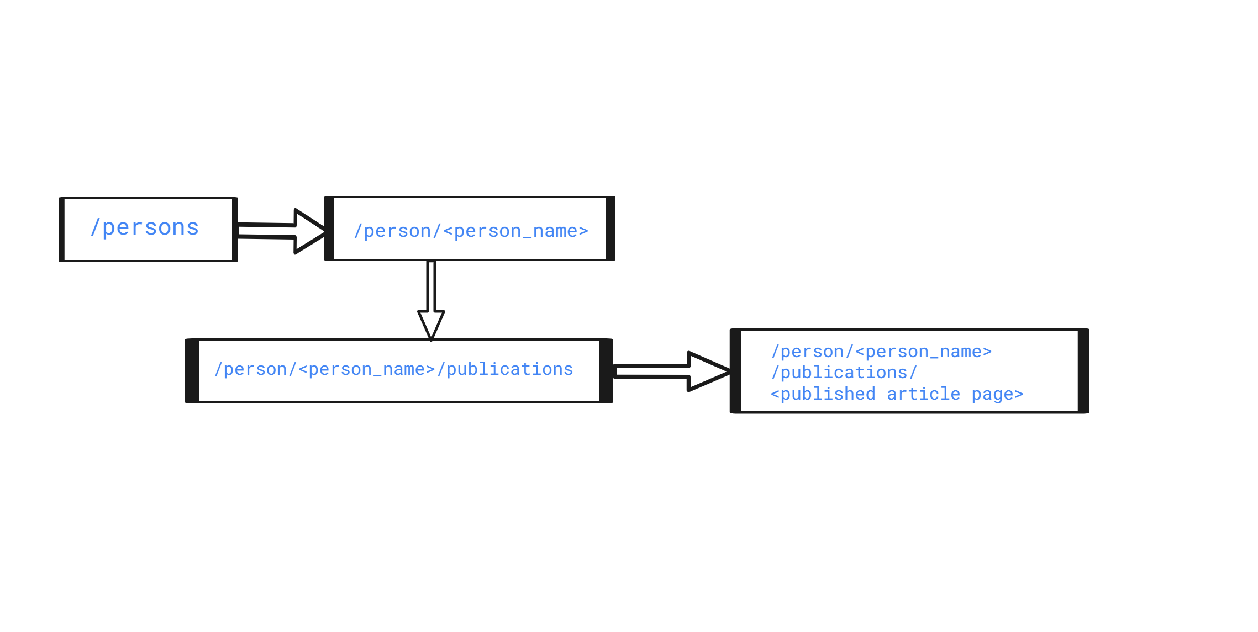

Figure Phases of crawling the website

The figure above shows the flow of the crawling process. The starting page being ‘/persons,’ first the crawler finds all the persons on the first page, using the ‘response.css’ method. For extracting the persons from the page, ‘*response.css('div.result-container')*’ was used.

Then for a single person on that page, the crawler gets the link for the person’s profile. Then by adding ‘/publications’ to the person’s url, the page where the individual’s all publications are present is reached. It was done by using the *‘response.follow(publication_url, callback = self.parse_person_pubs)’* method. The ‘publication_url’ referes to the person’s publications page which is used as the response for the function ‘parse_person_pubs’ being called using callback. The ‘parse_person_pubs’ function gathers links for all the publications present in the page and further uses the *‘follow ()’* method and follows every document’s links and calls the *‘get_abstract( )’* function. The *‘get_abstract()’* gets the document’s abstract section and lastly yields the person’s details and the person’s publications including its title and abstract.

The following list of steps sums up all the processes:

1. From the parse function, visit the starting url and gather attributes of all persons using the response.css method.
2. For an individuvial person, extract their publication url and call the parse_person_pubs function with the publication url as a response parameter.
3. From parse_person_pubs function, using the publication url passed from previous step, find all the published articles for that individual using the css response and extract their urls.
4. For a url, using follow method, call the get_abstract method with the published article’s url as response.
5. In the get_abstract method, using the passed url yields all the information of the author and the title and abstract of the published article.
6. Go to step 2 and follow the steps for all people on that page. After that, the next_page value gets initialized and using the follow method, the parse function gets recalled and the steps from 1 to 6 gets repeated unless all the pages are crawled.

When the crawling process is executed and completed, it provides a ‘.csv’ file as an output.

The steps above generalize the process of the crawling that was implemented in the code. In addition to crawling the website, the functionality of scheduling the crawler to crawl website automatically has also been added.

With the use of ‘CrawlerProcess’ method from scrapy and ‘TwistedScheduler’ method from ‘apscheduler’ was used to implement the automatic re-crawl scheduling. As the website being crawled has a low rate of being updated every day, the crawler has been scheduled to re-crawl every 14 days (about 2 weeks).

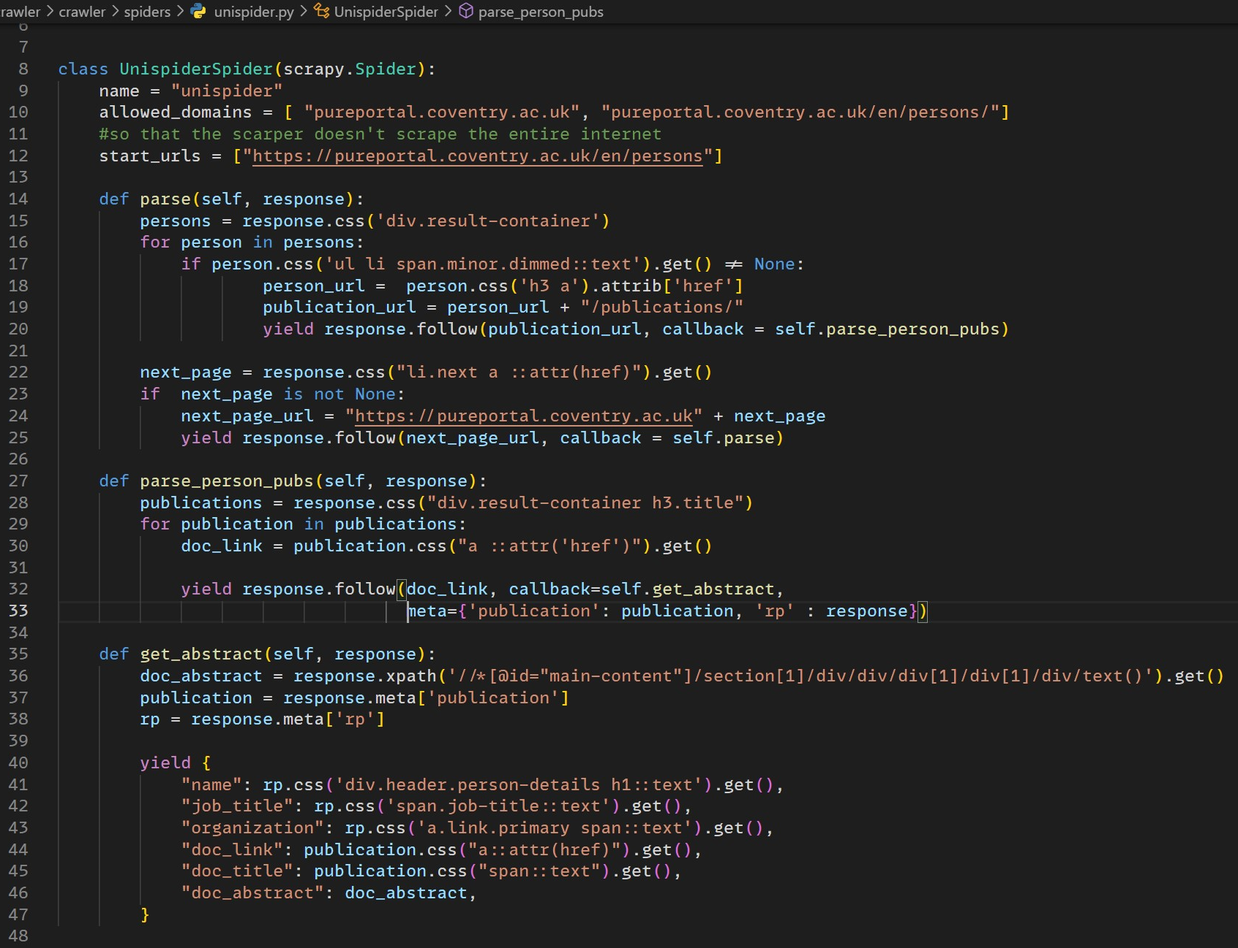

Figure Code of the Crawler

## Construction of the Query Processor Component

The data gathered by the crawler is the main ingredient for creating the search engine. Data crawled from websites is raw and not suitable for direct use to create any kind of models.

After the completion of the crawling process, the gathered raw csv data was imported into the program for the step of preprocessing. The following steps describe the flow of the text cleaning and prepping process.

### Cleaning Missing and Irrelevant Values

The raw data had some missing values as well as values that would not add much towards the dataset itself. Using the ‘pandas’ library, the dataset was loaded into a dataframe. The null values were dropped using the ‘dropna’ method and other rows which did not have relevant, and enough information were also dropped.

### Removing Stop Words and Special Characters

Stop words are highly occuring words such as *‘a,’ ‘an,’ ‘the,’ ‘is,’* etc. Such kinds of words can be found in all kinds of texts. When creating any kind of text classification models or invreted indexes or any kind of text related tasks, they donot provide any meaningful information. That is why stop words should be removed from datasets. Also, removing stop words reduces the size of dataset to an extent which helps in faster computations. (wisdomml, 2022)

A library called ‘nltk’ was used for this purpose. From ‘nltk,’ stopwords were downloaded. Then for a document from the dataframe, the words were splitted. The words were then transformend to lower case and then checked if it was a stopword. Finally, the punctuation was also removed from the documents.

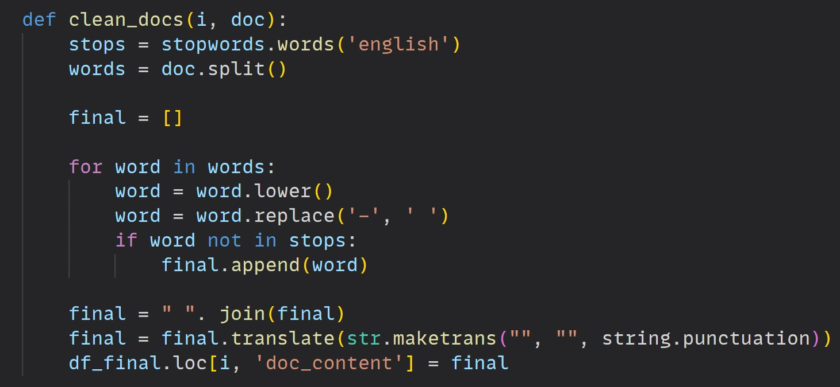

Figure Code Snippet of the function used to clean documents

### Calcuating TF-IDF and Cosine Similarity

TF-IDF stands for term frequency-inverse document frequency. When creating search engines, it helps to determine the importance of string representations in a document amongst a collection of documents (Simha, 2021).

TF or Term Frequecy works by examining the occurrence rate of a specific term of interest compared to the entire document. ID or Inverse document frequency examines the prevalence or rarity of a word within a corpus of documents.

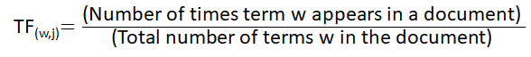

Figure Formula for calculating TF

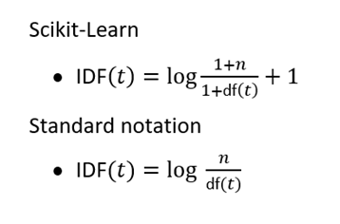

Figure Formula for calculating TDF (Sivarajah, 2020)

“Cosine similarity measures the similarity between two vectors of an inner product space. It is measured by the cosine of the angle between two vectors and determines whether two vectors are pointing in the same direction. It is often used to measure document similarity in text analysis.” (Jiawei Han, 2012) Cosine similarity helps in determining how similar two data entities are regardless of their scale or size. When calculating cosine similarity, the data objects from a dataset are treated as vectors. The cosine similarity between two vectors can be calcuated by using the formula as shown in the figure.

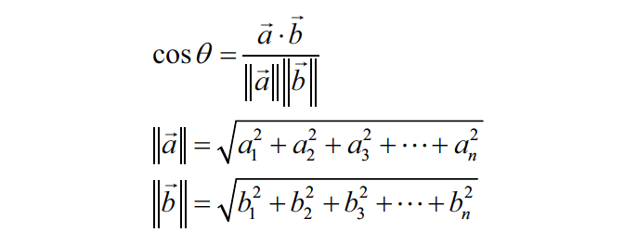

Figure Cosine Similarity (Karbhari, 2020)

The cosine similarity calculation provides value in range from 0 to 1, which can be inversed resulting in an angular value or ‘θ’. So,

* If θ = 0°, the angle between vectors a and b is zero, which means that they are similar.
* If θ = 90°, the angle between vectors a and b has increased, meaning those vectors are dissimilar.

TF-IDF and cosine similarity was implemented in the program using the ‘sklearn’ library. ‘Scikit-learn’ or ‘sklearn’ is a free machine learning library for Python programming language with a vast collection of machine learning tools and techniques.

After completing the process of cleaning, using ‘sklearn’ the ‘TfidfVectorizer’ and ‘cosine_similarity’ method was imported. An object of the ‘TfidfVectorizer’ was created and the documents were fitted and transformed to vectors. The output of the vectorizer was stored in a matrix, tfidf_matrix.

A query processor function was created like the text pre-processor for cleaning the query provided by the user in the web interface. The query processor was used to remove any kind of punctuation, stop words and special characters from the user’s query. The user’s processed and cleaned query and the tfidf matrix both were passed to the cosine_similarity function and the cosine similarity was calculated.

Then the web interface was used to present the documents that were relevant to the user’s query. A simple web interface mimicing the base layout of traditional search engines was implemented using Python Flask framework and the web interface was designed using simple HTML, CSS, and bootstrap.

## Subject Classification Using Different Machine Learning Algorithms

Text/subject classification is a technique used in machine learning that can be used to predict a category of text unseen by the model and assign pre-defined categories to it.

For this project, three different classification algorithms,

* Random Forest Classifier,
* Support Vector Machine (SVM) and
* Light Gradient Boosting Machine (LGBM) were used.

Random Forest Classifier is an ensemble classifier. It fits a number of decision tree classifiers on various sub-samples of the dataset and uses averaging to improve the predictive accuracy and control over-fitting (scikit-learn, n.d.). Support Vector Machine (SVM) is a machine learning algorithm used for classification, which works by finding a hyperplane in N-dimensional space that classifies the data points.

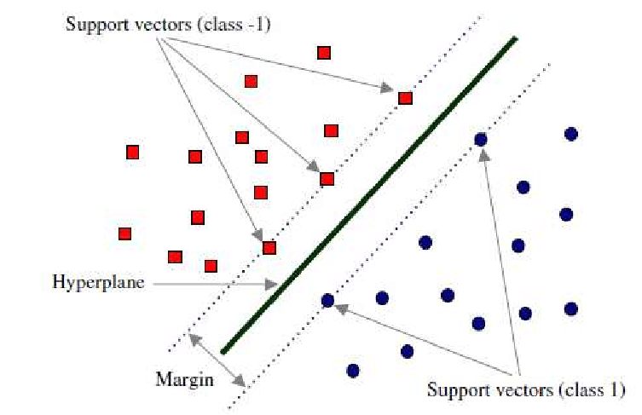

Figure Support Vector Machine (Baghaee, 2020)

Light GBM is a gradient boosting framework which is based on decision trees which is very efficient, fast, provides better accuracy and can handle large-scale data. (Corporation, n.d.)

All these algorithms were implemented by importing them from the scikit learn library. First, the dataset for training the models was downloaded from the web. For that purpose, the BBC news dataset was downloaded. The dataset had two columns, one with the text and another column had the respective category for that text. The three categories present in the dataset were *engineering*, *business,* and *arts*. Like previous steps, the database text was cleaned by removing stop words, punctuation and special characters, and the text was lemmatized.

After cleaning the document texts, the text data was splitted into train and test sets using the scikit learn’s train_test_split method. Then the training datas were fitted into the algorithms. Another metric called k-fold cross validation was also used to where k means the number of folds the provided data will be subjected to. It works by splitting the data into the specified number of folds, training the model on a subset of the data, and evaluating its performance on the remaining fold. This process is repeated for each fold, and the average scores for each metric are returned as the output. Scoring metrics like accuracy and weighted F1 score were also calculated.

The output and results are dicussed in the next section.

# Results and Discussion

The crawler component of the project after completing the execution produces a ‘.csv’ file with the following columns.

* Name (name)
* Job title (job_title)
* Organization (organization)
* Document URL (doc_link)
* Document Title (doc_title)
* Document Abstract (doc_abstract)

The screenshot of the file outputed by the crawler is added in the appendix. As the crawler was implemented such that it crawls the whole pureportal persons section, it can take quite a while to complete and extract all the data from the website.

The file was used as dataset for the Search engine aspect of the project. Upon executing all the processes as discussed in previous sections, the result was a web platform with a search box to type the query and a search button to execute the search function. The image below shows the resulting look of the web platform.

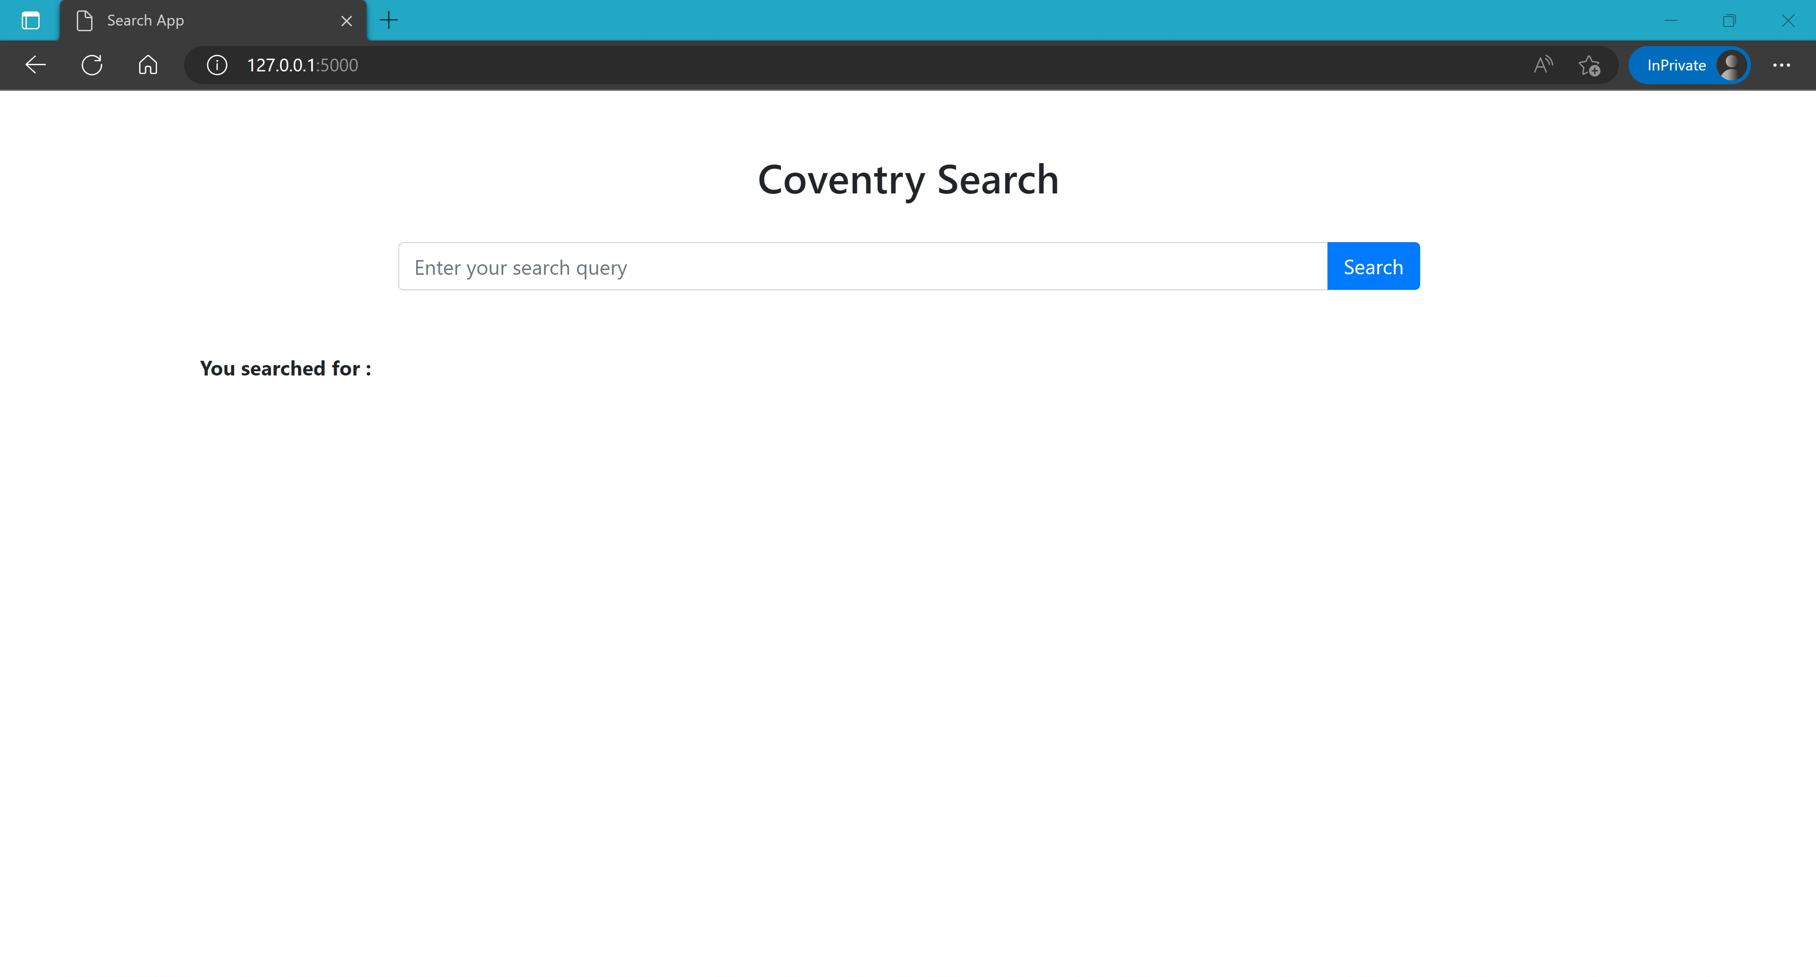

Figure Search Engine UI

Upon typing the query and pressing the search button, it took around 6-8 seconds to execute and provide the output relevant to the user’s query. The output contains all necessary informations as well as the cosine similarity. The output is presented in a list like readable layout as shown in the figure below.



Figure User Query search and results

As seen from the figure, the search engine provided the information relevant to the user’s query. A cosine similarity of 0.64 can also be seen in the first result for the query which denotes a good similarity between the user’s query and the result. This shows that the query processing is working properly.

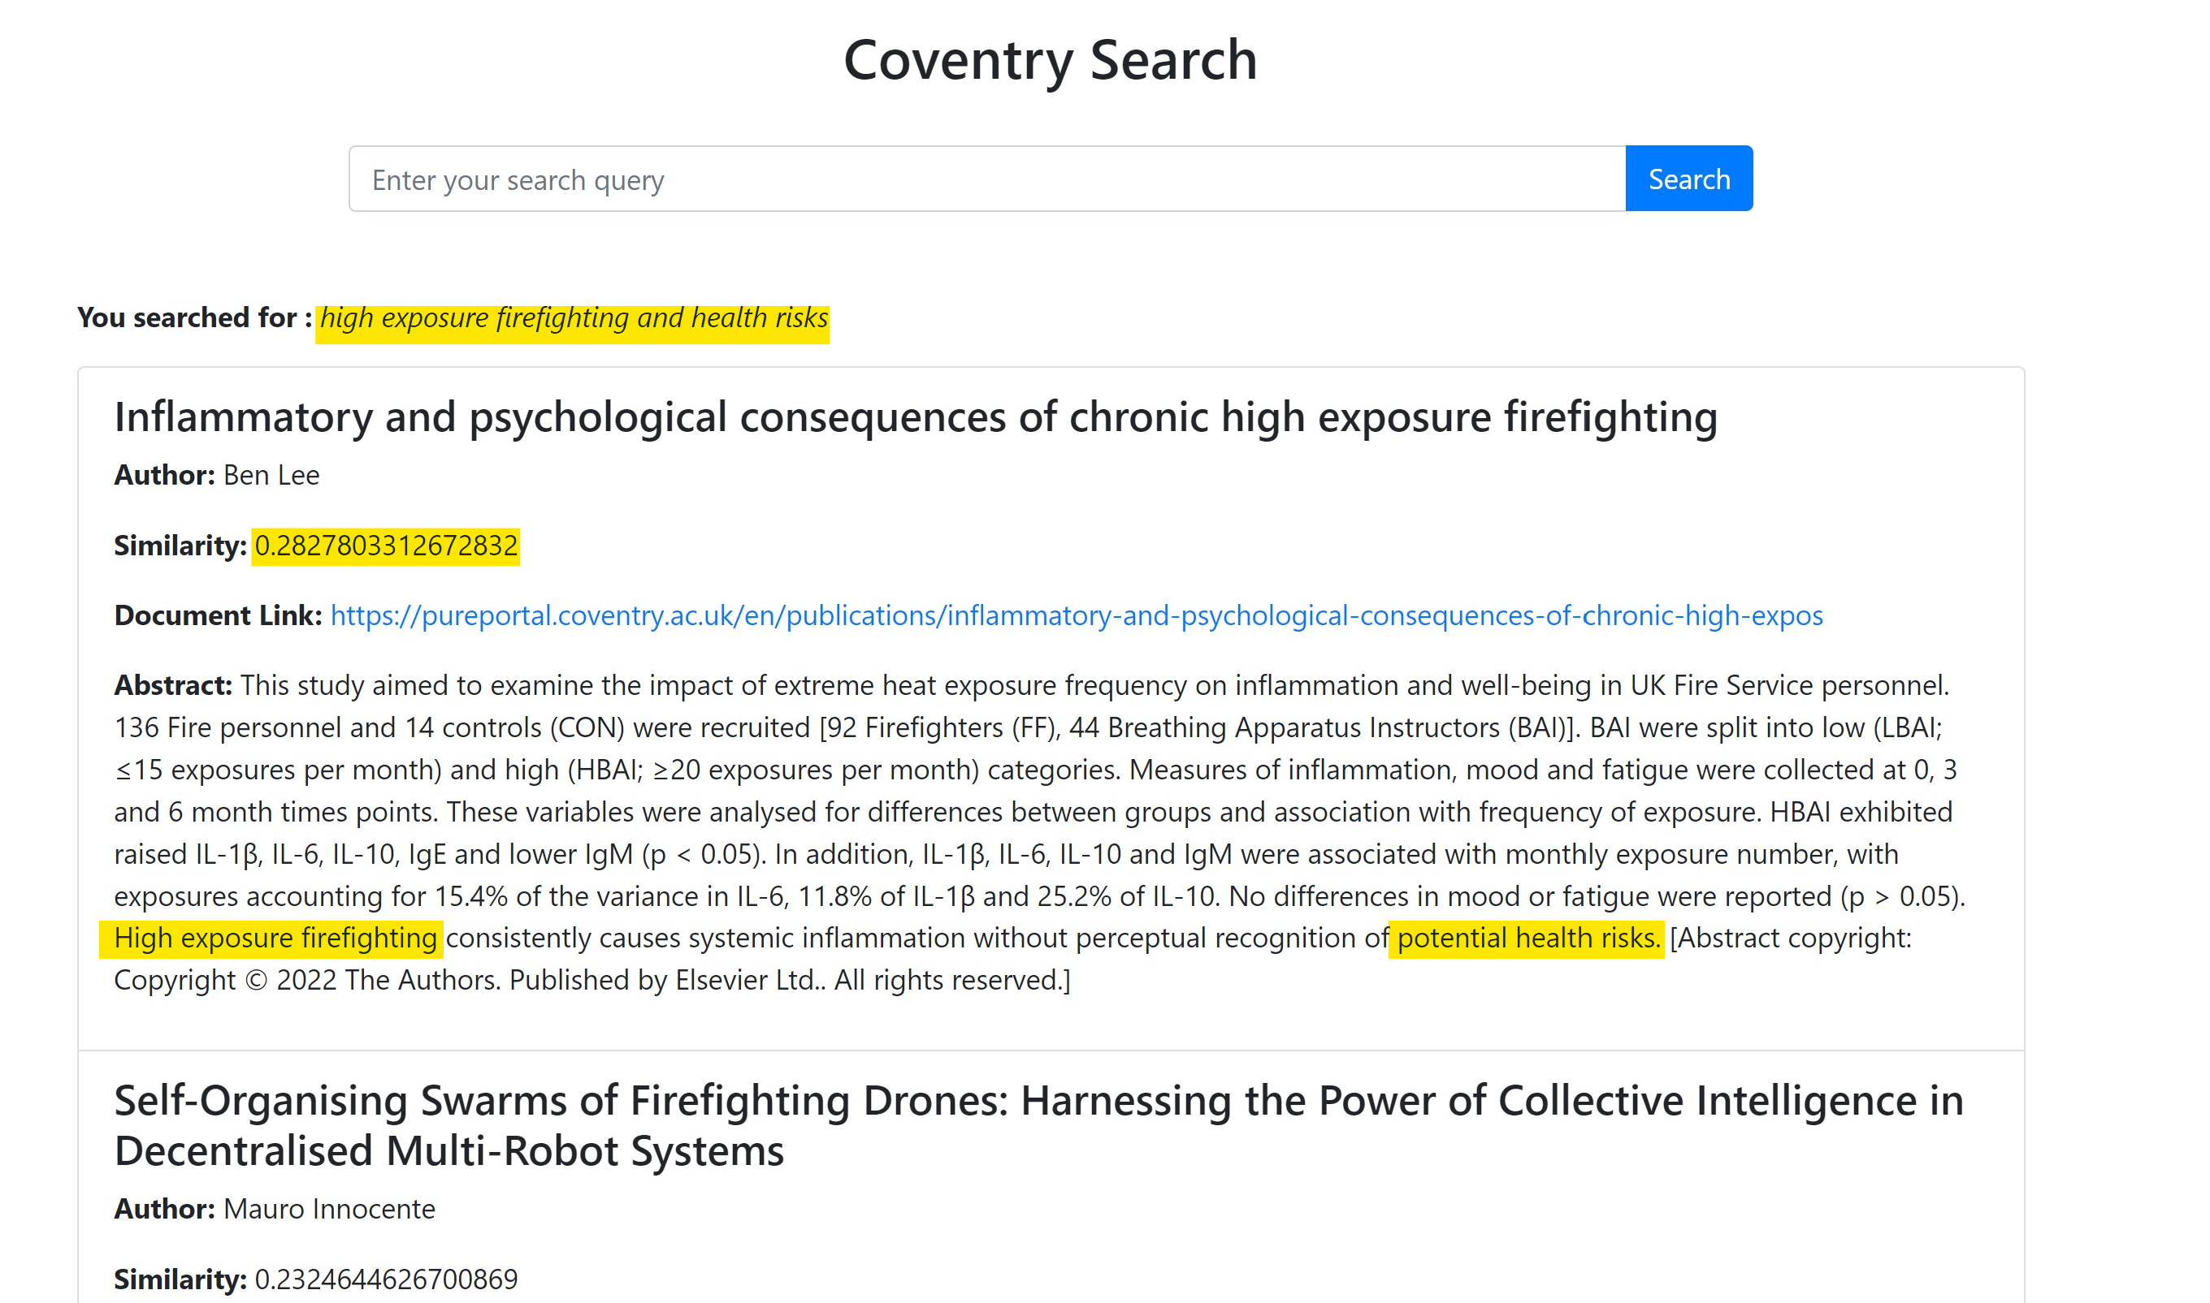

Figure Searching another query with the query terms highlighted in the result

The text classification algorithms were programmed and executed separately from the search engine. As already discussed, the algorithms that were used for classification were Random Forest, SVM and Light GBM. The results of the scoring metrics for all the algorithms are as follows:

|  |  |  |  |  |
| --- | --- | --- | --- | --- |
|  | test_accuracy | test_precision_weighted | test_recall_weighted | test_f1_weighted |
| 0 | 0.962428 | 0.964164 | 0.962428 | 0.962479 |
| 1 | 0.968208 | 0.968513 | 0.968208 | 0.968253 |
| 2 | 0.965217 | 0.965751 | 0.965217 | 0.965067 |

Figure Scoring Metrics - Random Forest Classifier

|  |  |  |  |  |
| --- | --- | --- | --- | --- |
|  | test_accuracy | test_precision_weighted | test_recall_weighted | test_f1_weighted |
| 0 | 0.979769 | 0.980043 | 0.979769 | 0.979722 |
| 1 | 0.976879 | 0.977071 | 0.976879 | 0.976883 |
| 2 | 0.982609 | 0.983078 | 0.982609 | 0.982625 |

Figure Scoring Metrics - Support Vector Machine

|  |  |  |  |  |
| --- | --- | --- | --- | --- |
|  | test_accuracy | test_precision_weighted | test_recall_weighted | test_f1_weighted |
| 0 | 0.959538 | 0.960092 | 0.959538 | 0.959521 |
| 1 | 0.947977 | 0.948513 | 0.947977 | 0.948130 |
| 2 | 0.968116 | 0.969117 | 0.968116 | 0.968185 |

Figure Scoring Metrics - Light GBM Classifier

The three tables above show the test scores of the text classifiers. The three rows of values arise from the 3-fold cross validation performed in the process. From the tables, the Support Vector Machine algorithm has the best performance of all. So, the **Support Vector Machine** classifier was chosen for predicting the categories.

The images below show the output of the classifiers when unseen data is used as input for them to classify the category of.

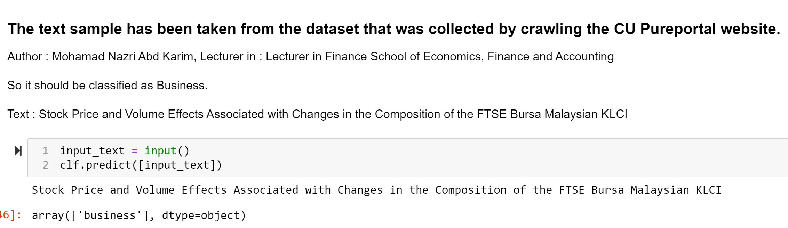

Figure Text Classification

In the above figure, the sample text was taken from an article published by the CU author, Mohamad Nazri. The classifier was trained on BBC dataset, so this text data was unseen data for the model.

As the SVM classifier has an F1-score of 0.98, the model predicted the text’s category successfully as “business”.

Similarly, below are some more examples of the predictions made by the model on text taken from articles published by authors on Pureportal.

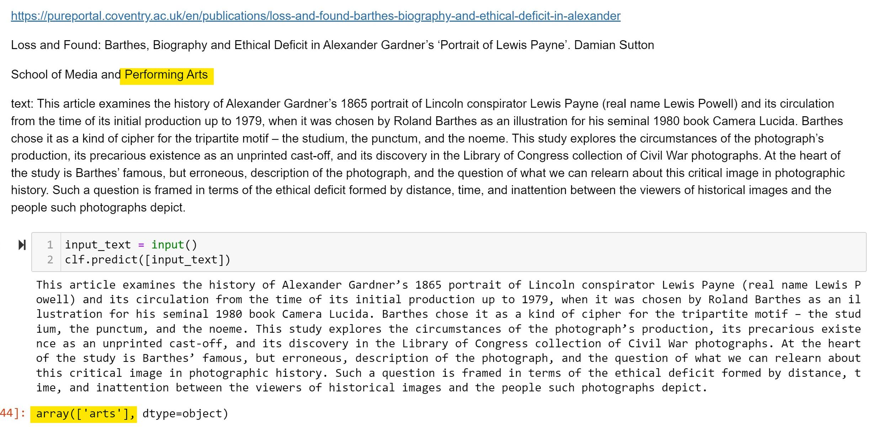

Figure Arts Text classified as 'arts' by classifier

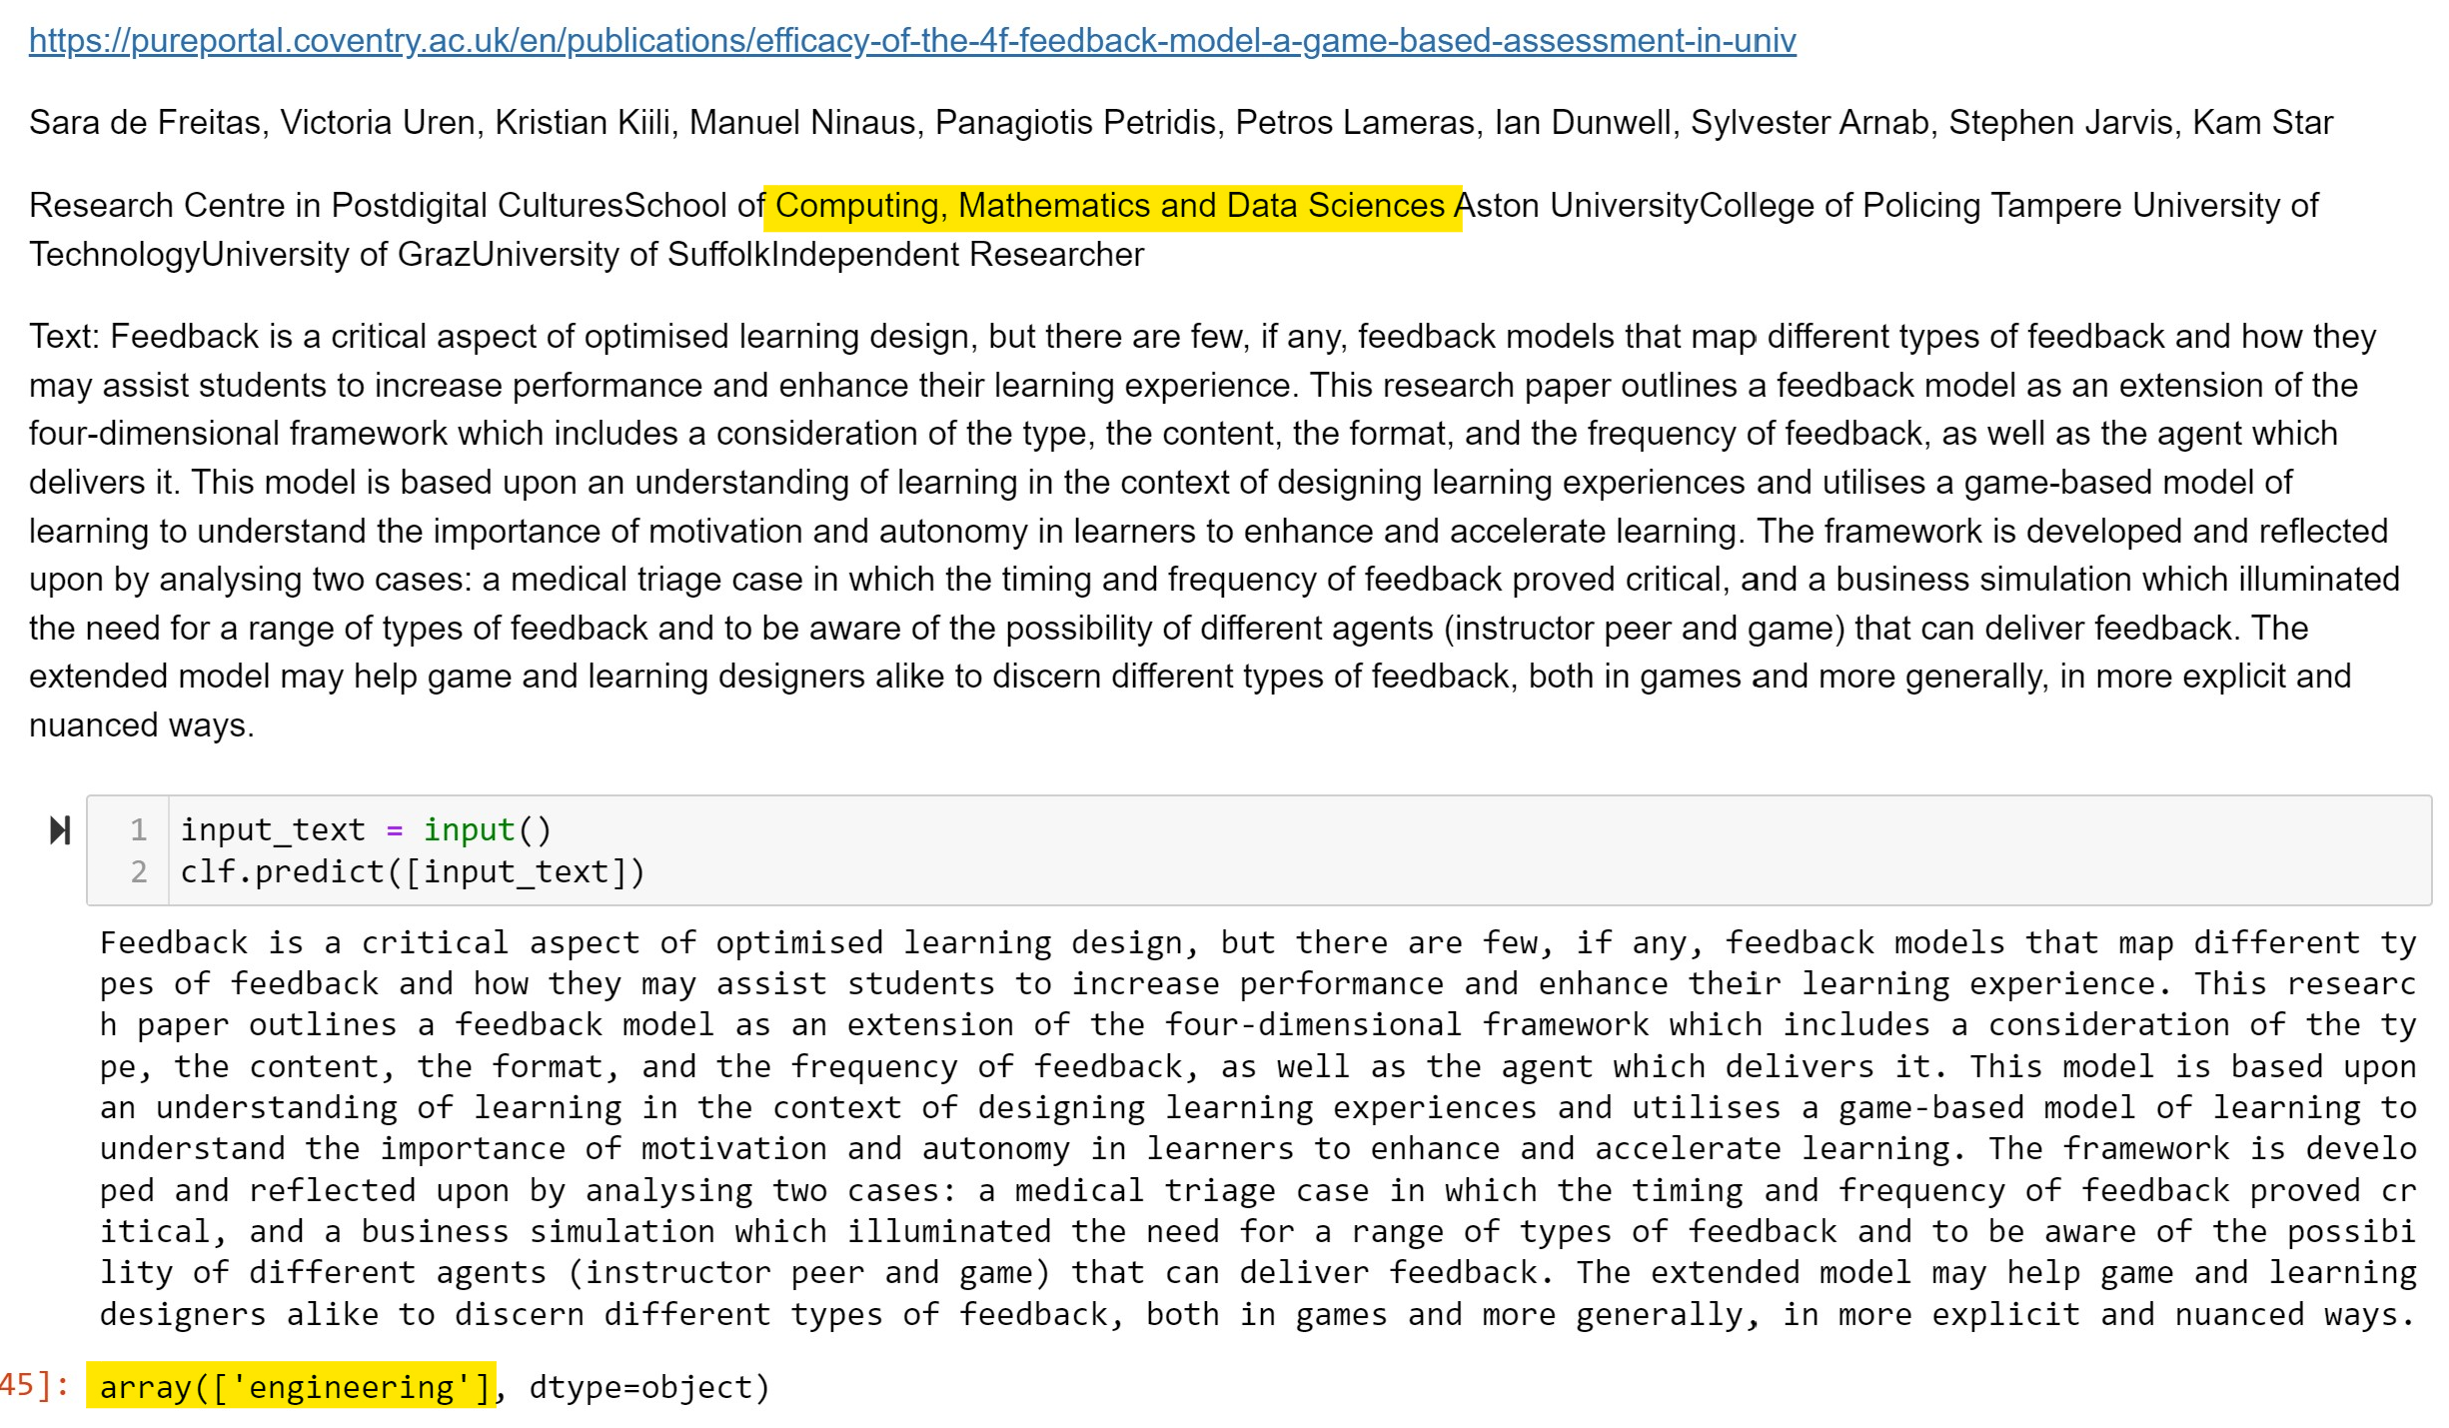

Figure Engineering text classified as 'engineering'

# References

Baghaee, H. a. (2020, September). Support Vector Machine-Based Islanding and Grid Fault Detection in Active Distribution Networks. *EEE Journal of Emerging and Selected Topics in Power Electronics*, 2385 - 2403.

Corporation, M. (n.d.). *Welcome to LightGBM’s documentation!* Retrieved from LightGBM : https://lightgbm.readthedocs.io/en/v3.3.2/

Jiawei Han, M. K. (2012). 2 - Getting to Know Your Data. In M. K. Jiawei Han, *Data Mining: Concepts and Techniques* (pp. 39-82). Morgan Kaufmann. Retrieved from https://www.sciencedirect.com/topics/computer-science/cosine-similarity#:~:text=Cosine%20similarity%20measures%20the%20similarity,document%20similarity%20in%20text%20analysis.

Karbhari, V. (2020, January 29). *What is a cosine similarity matrix?* Retrieved from Medium: https://medium.com/acing-ai/what-is-cosine-similarity-matrix-f0819e674ad1

Marr, B. (2018, May 21). *How Much Data Do We Create Every Day? The Mind-Blowing Stats Everyone Should Read*. Retrieved 6 2, 2023, from https://www.forbes.com/sites/bernardmarr/2018/05/21/how-much-data-do-we-create-every-day-the-mind-blowing-stats-everyone-should-read/?sh=6b9302dd60ba

scikit-learn. (n.d.). *sklearn.ensemble.RandomForestClassifier*. Retrieved from scikit learn: https://scikit-learn.org/stable/modules/generated/sklearn.ensemble.RandomForestClassifier.html

Simha, A. (2021, October 7). *Understanding TF-IDF for Machine Learning*. Retrieved from Capital One: https://www.capitalone.com/tech/machine-learning/understanding-tf-idf/

Sivarajah, S. (2020, June 13). *“Sklearn’s TF-IDF” vs “Standard TF-IDF”*. Retrieved from Medium: https://towardsdatascience.com/how-sklearns-tf-idf-is-different-from-the-standard-tf-idf-275fa582e73d

Wikipedia. (2023, May 22). *Vertical Search*. Retrieved from Wikipedia: https://en.wikipedia.org/wiki/Vertical_search

wisdomml. (2022, August 5). *What are Stop words in NLP and Why we should remove them?* Retrieved from Wisdom ML: https://wisdomml.in/what-are-stopwords-in-nlp-and-why-we-should-remove-them/

# Appendices

Github link: <https://github.com/manashb21/IRassignment> (The video showing the commands and program being executed is also on the same github respository.)

Screenshots of code for scarpy crawler:

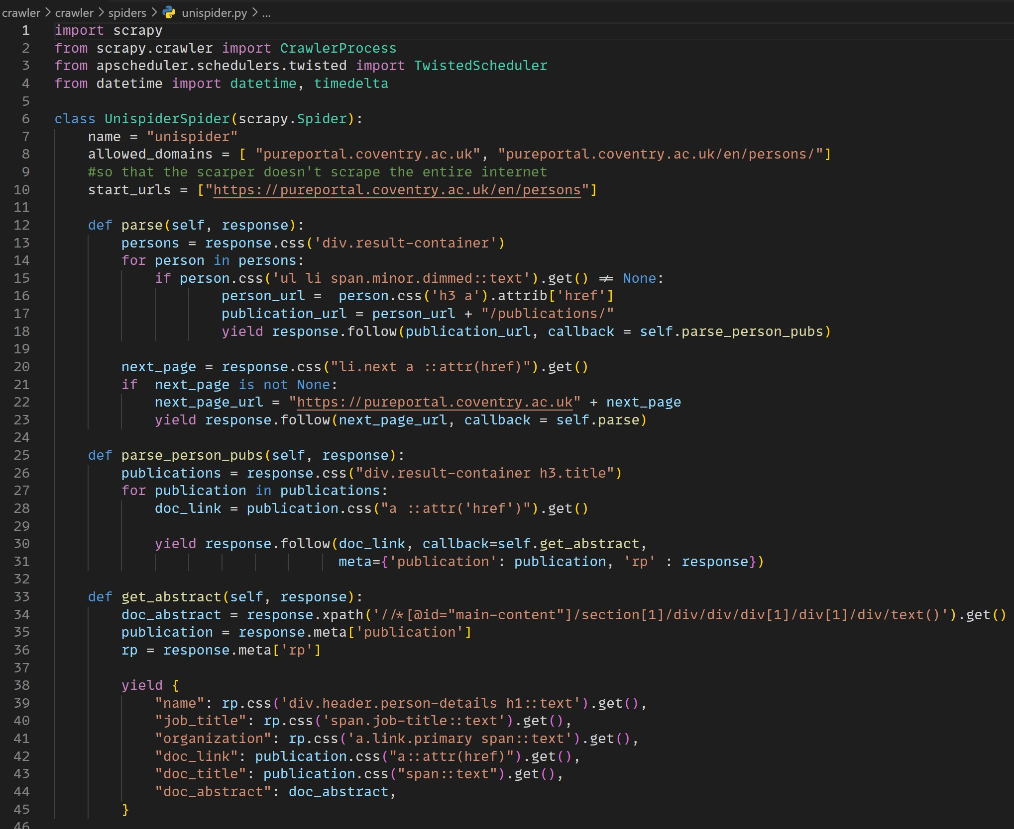

Scheduler Implementation 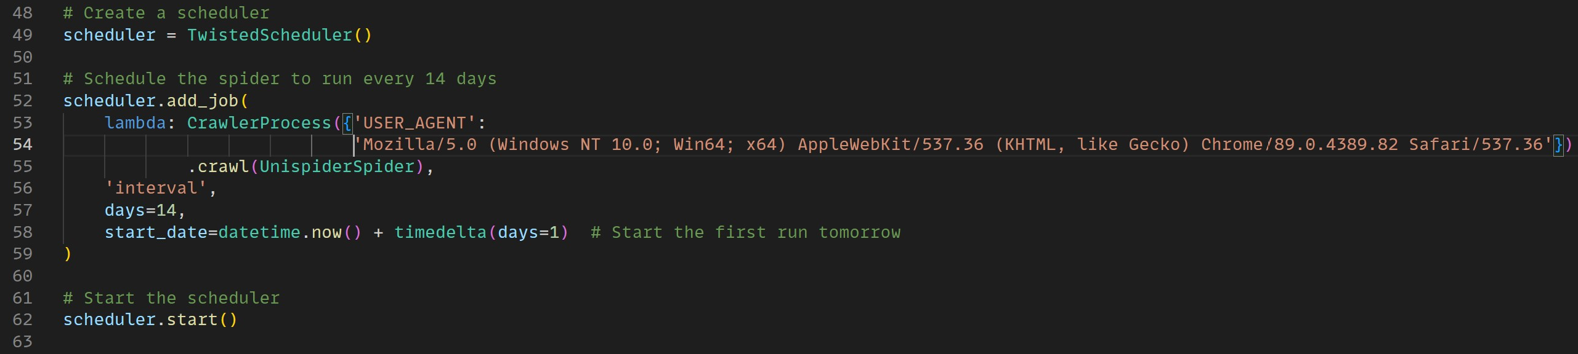

Output CSV file from the Crawler: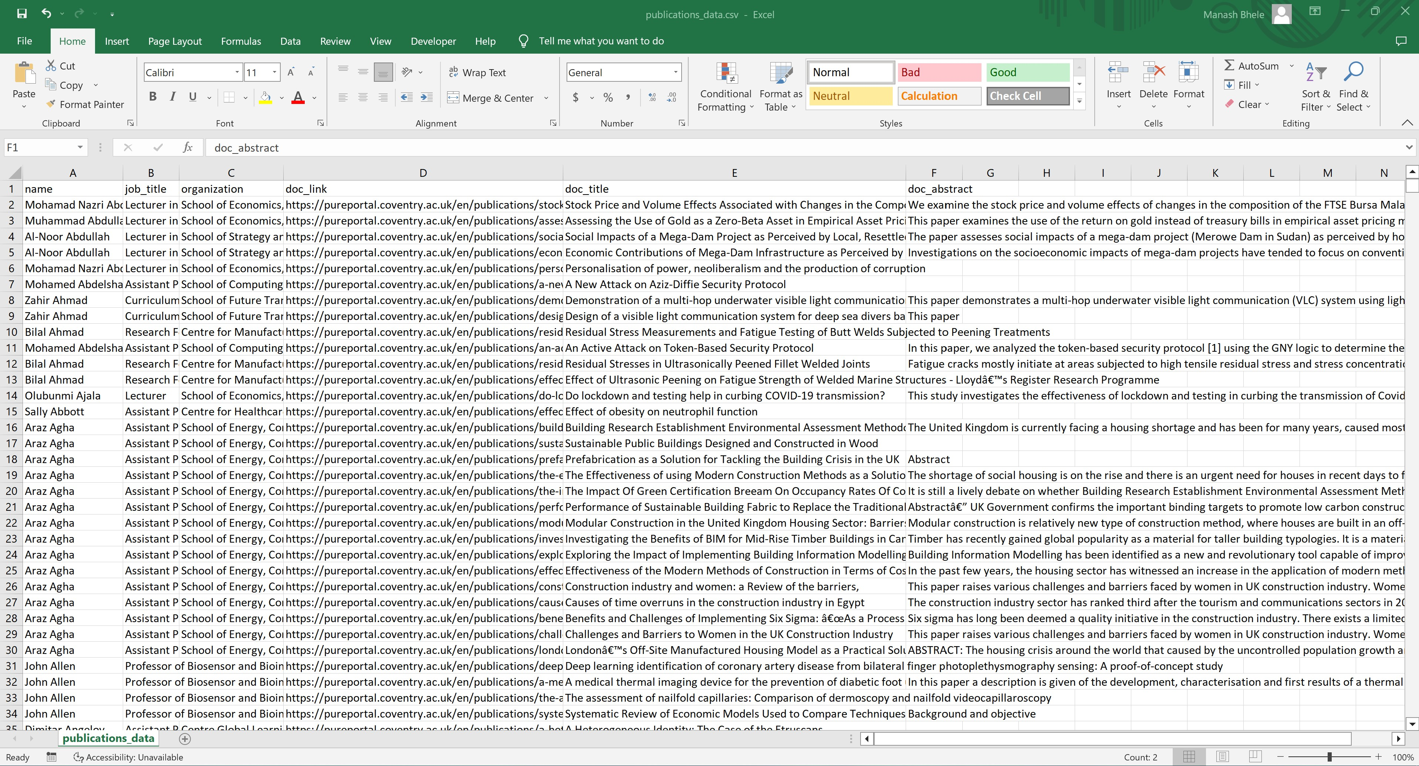Python Flask Web app: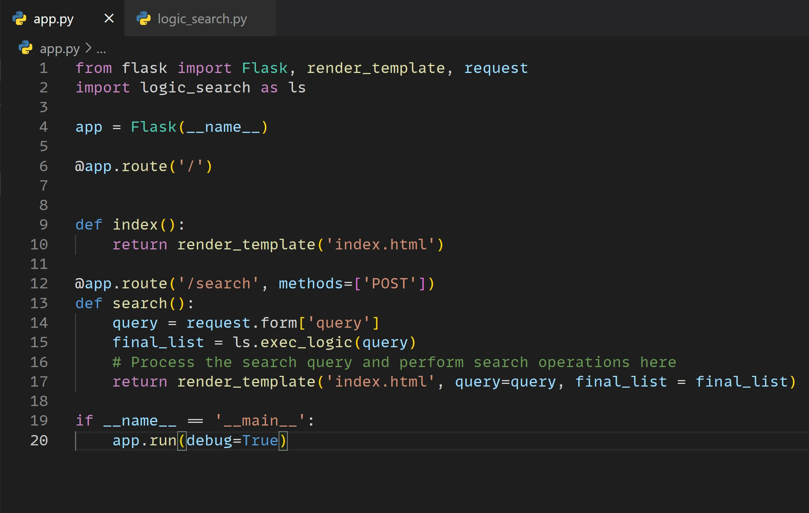

Search Engine Code:

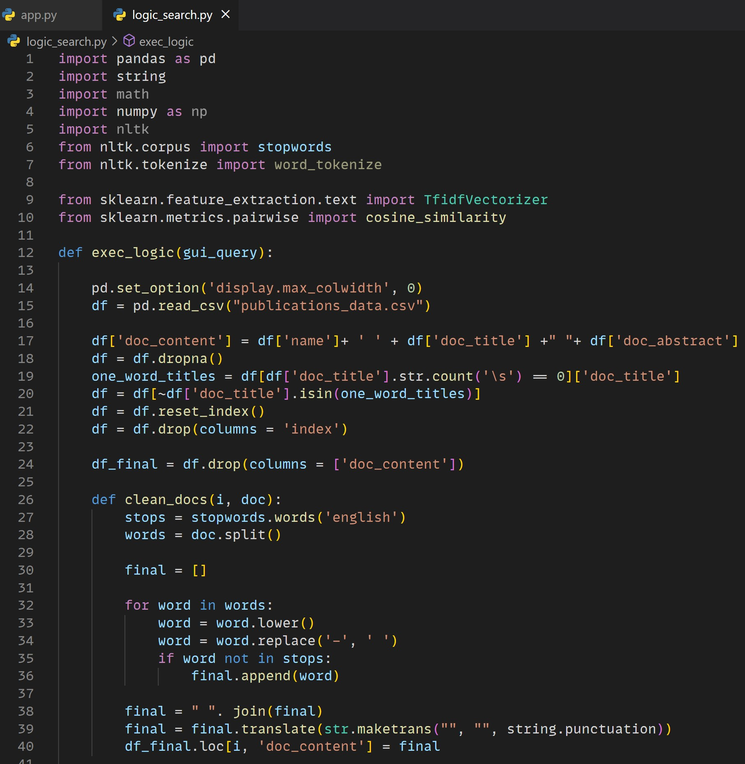

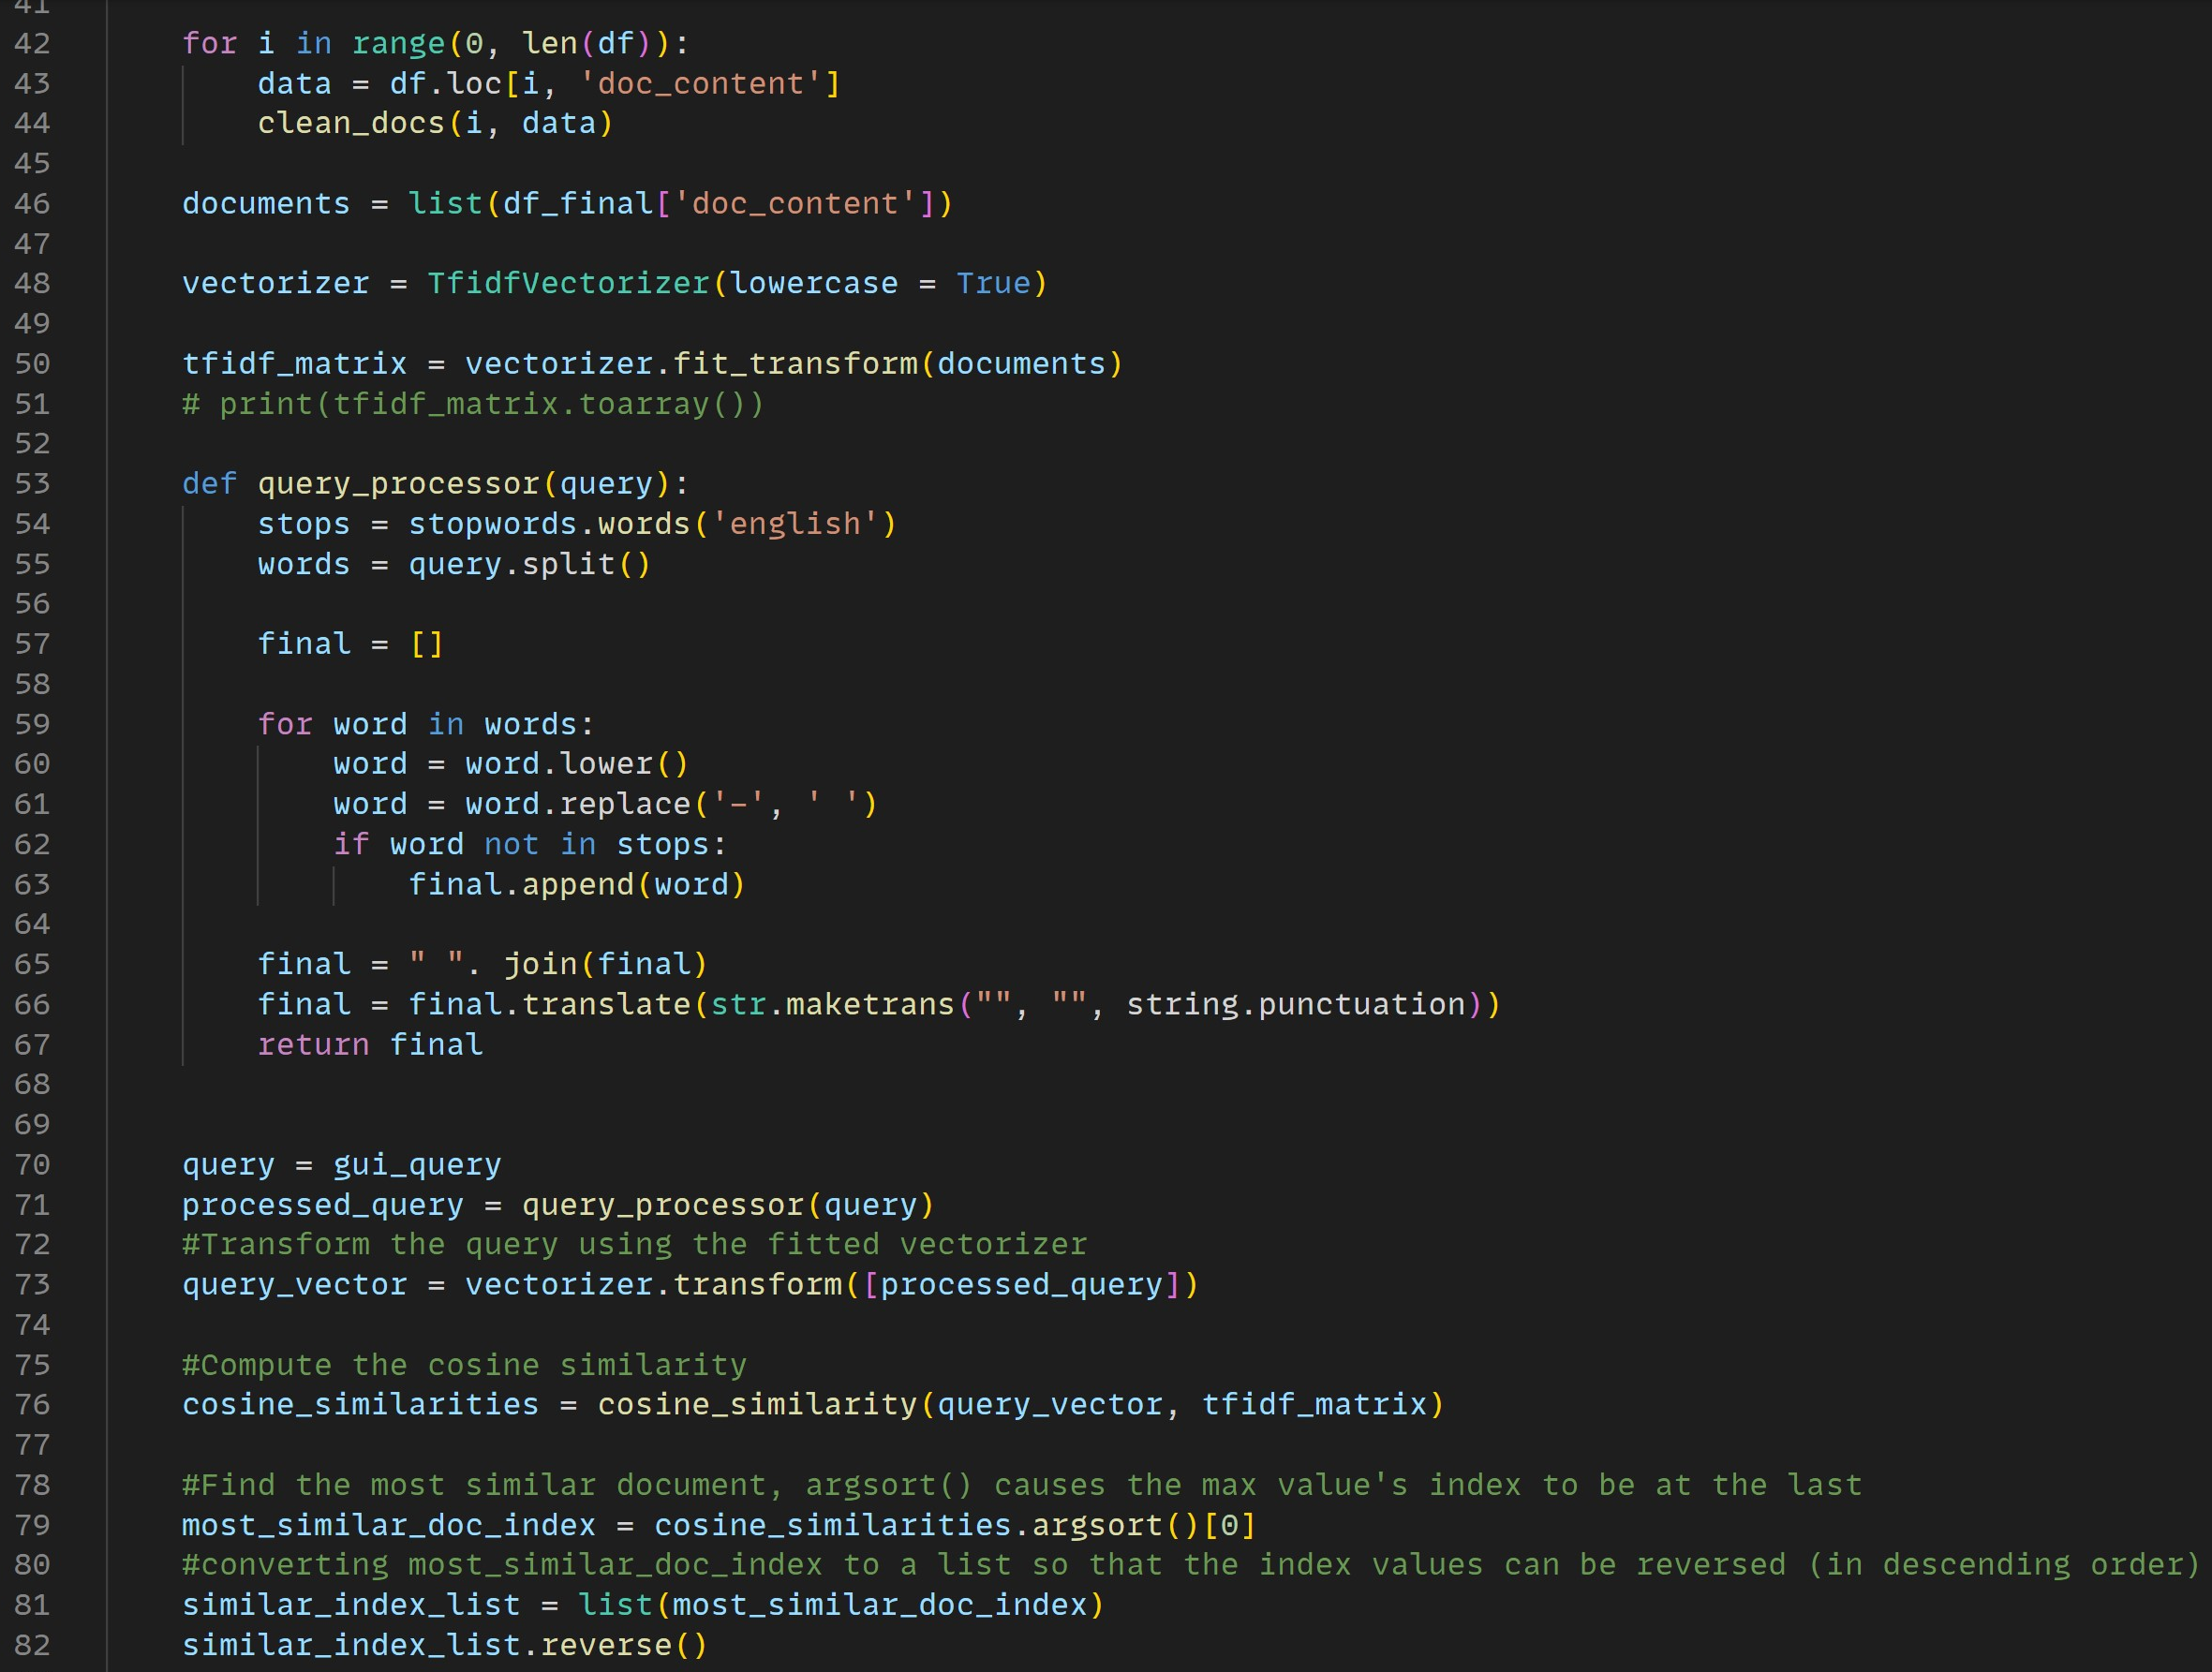

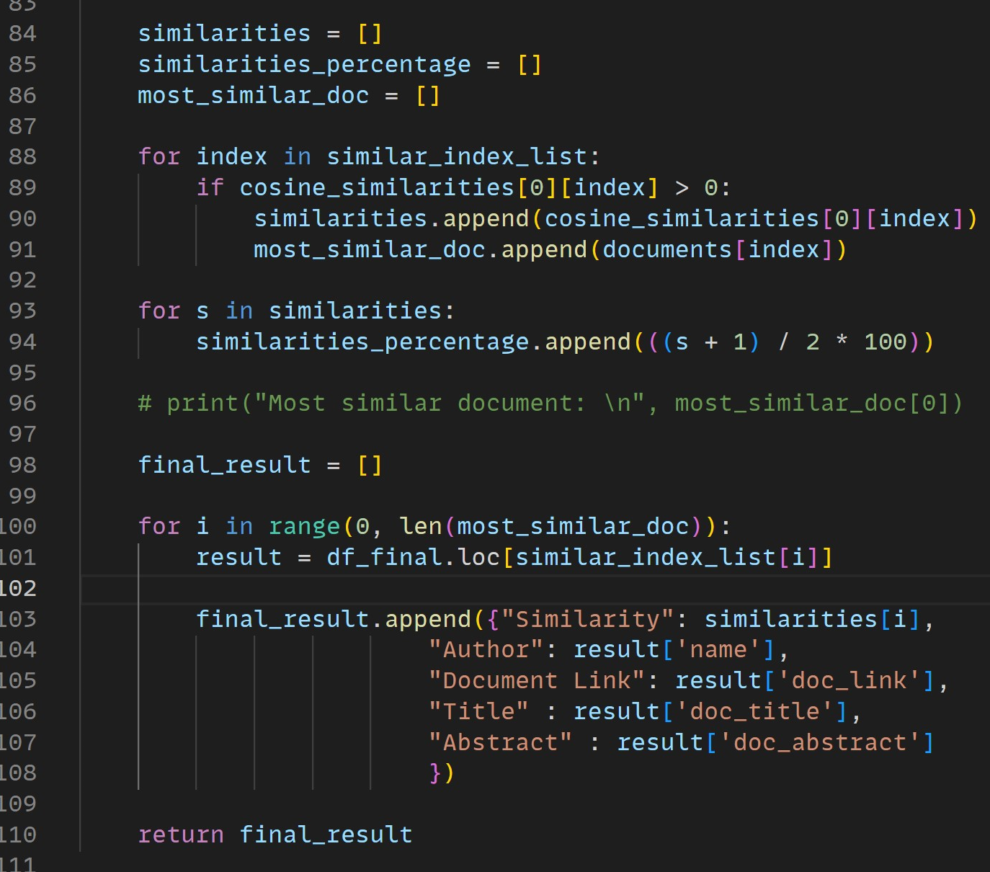

Text Classifier Code:



